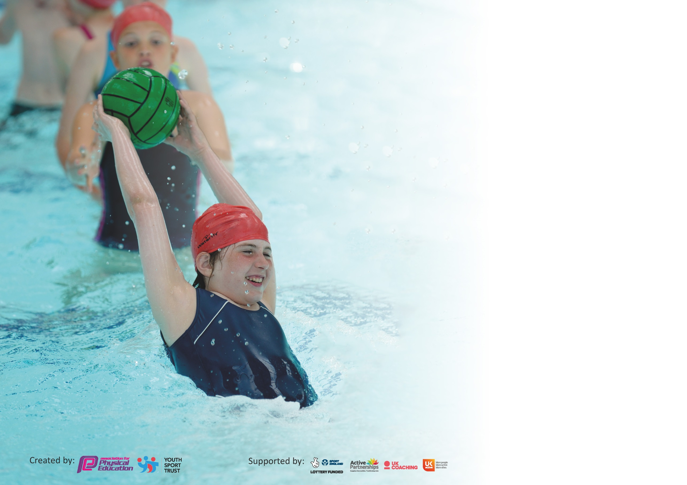

It is important that your grant is used effectively and based on school need. The Education Inspection Framework (Ofsted 2019 p64) makes clear there will be a focus on ‘whether leaders and those responsible for governors all understand their respective roles and perform these in a way that enhances the effectiveness of the school’.

Under the Quality of Education criteria (p41) inspectors consider the extent to which schools can articulate their curriculum (INTENT), construct their curriculum (IMPLEMENTATION) and demonstrate the outcomes which result (IMPACT).

To assist schools with common transferable language this template has been developed to utilise the same three headings which should make your plans easily transferable between working documents.

Schools must use the funding to make additional and sustainable improvements to the quality of Physical Education, School Sport and Physical Activity (PESSPA) they offer. This means that you should
use the Primary PE and Sport Premium to:

- Develop or add to the PESSPA activities that your school already offer
- Build capacity and capability within the school to ensure that improvements made now will benefit pupils joining the school in future years

Please visit gov.uk for the revised DfE guidance including the 5 key indicators across which schools should demonstrate an improvement. This document will help you to review your provision and to report your spend. DfE encourages schools to use this template as an effective way of meeting the reporting requirements of the Primary PE and Sport Premium.

We recommend you start by reflecting on the impact of current provision and reviewing the previous spend.

Schools are required to publish details of how they spend this funding as well as on the impact it has on pupils’ PE and sport participation and attainment by the end of the summer term or by 31st July 2020 at the latest.

We recommend regularly updating the table and publishing it on your website throughout the year. This evidences your ongoing self-evaluation of how you are using the funding to secure maximum, sustainable impact. Final copy must be posted on your website by the end of the academic year and no later than the 31st July 2020. To see an example of how to complete the table please click HERE.

Support for review and reflection - considering the 5 key indicators from DfE, what development needs are a priority for your setting and your pupils now and why? Use the space below to reflect on previous spend and key achievements and areas for development.

Key achievements to date until July 2019: | Areas for further improvement and baseline evidence of need:
- The successful implementation of a more easily accessible and effective curriculum through the use of online Real PE to new staff as well as current staff.  - The effective introduction of and implementation of a new sports coach in school to improve the achievements of children and their well-being as well as to provide professional development opportunities to staff.  - The school has become more positively engaged with being active in general and children have voiced much more positive views about physical activity.  - The development of more positive lunchtime experiences for children through better information sharing with lunchtime staff, more frequently received feedback from children, relevant plans put in place and training delivered to lunch time staff accordingly. | - Assessment of Real PE still needs to become more consistent across year groups in order to use this data to inform further planning and interventions.  - Taught and developed skills to encourage positive lunchtime experiences for children needs to be practised more consistently and monitored and reflected upon more regularly.

Meeting national curriculum requirements for swimming and water safety.
What percentage of your current Year 6 cohort swim competently, confidently and proficiently over a distance of at least 25 metres?  N.B. Even though your pupils may swim in another year please report on their attainment on leaving  primary school at the end of the summer term 2020. | 77%
What percentage of your current Year 6 cohort use a range of strokes effectively [for example, front crawl, backstroke and breaststroke]? | 77%
What percentage of your current Year 6 cohort perform safe self-rescue in different water-based situations? | 80%
Schools can choose to use the Primary PE and Sport Premium to provide additional provision for swimming but this must be for activity over and above the national curriculum requirements. Have you used it in this way? | No, not this year as it was used last year to provide swimming lessons to those in Y3, 4, 5 and 6 who could not competently swim and so it will be more beneficial to wait and repeat this in a couple of years time.

Action Plan and Budget Tracking
Capture your intended annual spend against the 5 key indicators. Clarify the success criteria and evidence of impact that you intend to measure to evaluate for pupils today and for the future.

Academic Year: 2019/20 | Total fund allocated: £17,680 | Date Updated: 29/4/20
Key indicator 1: The engagement of all pupils in regular physical activity – Chief Medical Officer guidelines recommend that primary school pupils undertake at least 30 minutes of physical activity a day in school |  |  |  | Percentage of total allocation:
 |  |  |  | 0%
Intent | Implementation |  | Impact
Your school focus should be clear what you want the pupils to know and be able to do and about  what they need to learn and to  consolidate through practice: | Make sure your actions to achieve are linked to your intentions: | Funding allocated: | Evidence of impact: what do pupils now know and what can they now do? What has changed?: | Sustainability and suggested next steps:
- For all children to have regular opportunities to engage with a personal best challenge (displayed in the corridor and updated 2 weekly) | - Create a large display for the personal best challenge with an area for children to write their personal best, 1 minute timers and recording material for them to use when attempting the challenge.  - Provide an assembly to the whole school explaining and modelling the personal best challenge board to ensure all pupils understand how to use it appropriately and when appropriate times throughout the school day are to do so. | £0 | - The appeared increase in accuracy of recording personal best results shows that children have developed a better understanding of what this means and the importance of being trust-worthy and honest about scores and comparing scores to their own rather than competing with others.  - Displayed evidence that children from many year groups are engaging with this regularly indicates an increase in their levels of physical activity and enjoyment. | - Continue to verbally acknowledge and congratulate children who appear to be using the board regularly to encourage more children to do so – option to allocate prizes to children who are regularly using it.  - Continue to regularly check on and restock the resources needed for this and update the personal best challenge at least every 2 weeks.
Key indicator 2: The profile of PESSPA being raised across the school as a tool for whole school improvement |  |  |  | Percentage of total allocation:
 |  |  |  | 8%
Intent | Implementation |  | Impact
Your school focus should be clear what you want the pupils to know and be able to do and about  what they need to learn and to  consolidate through practice: | Make sure your actions to achieve are linked to your intentions: | Funding allocated: | Evidence of impact: what do pupils now know and what can they now do? What has changed?: | Sustainability and suggested next steps:
- Real PE online curriculum subscription continued, enabling all teachers to access effective and progressive planning weekly.  - A range of before and after school clubs offered throughout the academic year. | - Meet with new staff to introduce them to Real PE and guide them on how to use it effectively.  - REAL PE lesson observations of staff to ensure consistent and effective use.  - Gather opinions and votes from all children on which clubs they would like and whether they prefer these to be before or after school.  - Send an extra invitation to a free before or after school club to all pupil premium children. | £245 | - Positive feedback from teachers has highlighted that they feel REAL PE is accessible to all and allows all children to learn and develop.  - Observations showed that teachers have use planning to deliver engaging lessons which allow all pupils to be involved in physical education and make good progress.  - Engagement in clubs has increased from Autumn term when attendance average was  - On receiving free before and after school club invitations, ___ pupil premium children took up this offer and engaged with at least 1 club per week. | - Ensure any new staff are trained in the delivery of Real PE and feel confident at using it effectively.  - When possible, do further lesson observations to see if areas of development from the previous ones have been met and to potentially inform any future delivery of staff development.  - Continue to gather children’s opinions and votes on clubs and use this to subsequently plan and provide a range of clubs to suit all children.  - Continue to actively encourage participation of pupil premium children in free before and after school clubs by sending regular invitations.

Key indicator 3: Increased confidence, knowledge and skills of all staff in teaching PE and sport |  |  |  | Percentage of total allocation:
 |  |  |  | 82%
Intent | Implementation |  | Impact
Your school focus should be clear | Make sure your actions to | Funding | Evidence of impact: what do | Sustainability and suggested
what you want the pupils to know | achieve are linked to your | allocated: | pupils now know and what | next steps:
and be able to do and about | intentions: |  | can they now do? What has
what they need to learn and to |  |  | changed?:
consolidate through practice:
- Energise Sports Coach has mentored staff to enable them to develop their confidence, knowledge and skills in teaching PE and sports | - Staff members shadowed/observed the health mentor to gain skills from him. Engaged in regular conversations with him to share ideas on the teaching of PE and sport. Health mentor has supported teachers and classes in competitions and sport engagement both outside and within school. | £15,500 | - The delivery of PE and sports has become more consistently effective across school.  - Staff have expressed they feel more confident in the delivery of PE.  - Children gain more from PE lessons/ have made further progress due to these being more effectively delivered. | - Impact data to be recorded and monitored to ensure effective sustainability of Sports Coach.
Key indicator 4: Broader experience of a range of sports and activities offered to all pupils |  |  |  | Percentage of total allocation:
 |  |  |  | 4%
Intent | Implementation |  | Impact
Your school focus should be clear | Make sure your actions to | Funding | Evidence of impact: what do | Sustainability and suggested
what you want the pupils to know | achieve are linked to your | allocated: | pupils now know and what | next steps:
and be able to do and about | intentions: | £900 | can they now do? What has
what they need to learn and to |  |  | changed?:
consolidate through practice:
Additional achievements:  - Ensure children have access to a variety of equipment and opportunities to practise and engage with various sports and activities throughout the school day | - Gather votes and opinions of children on what type of equipment they feel would benefit them to be able to engage with at break and lunchtimes. Purchase resources based on this.  - Deliver lunchtime supervisors training to ensure staff are skilled to encourage the engagement of children in a variety of sports and activities. |  | Children have become more engaged in meaningful activities at lunch and break times resulting in less issues. This is evident through the reduction in sanctions received: ___ red cards were issued in Autumn term and only __ in Spring term. The amount of rewards (raffle tickets) has increased too as has the number of lunchtime certificates given out weekly for positive behaviour.  Lunch supervisors have also reported an improvement in lunchtime behaviour and engagement. | - Regularly monitor lunchtime behaviour and activity engagement.  - Continue to do half termly checks to ensure resources are plentiful and effective at offering a range of sports and activity opportunities.  - Continue to provide lunchtime supervisor training to ensure all staff have the skills and knowledge to provide children with meaningful opportunities.

Key indicator 5: Increased participation in competitive sport |  |  |  | Percentage of total allocation:
 |  |  |  | 6%
Intent | Implementation |  | Impact
Your school focus should be clear | Make sure your actions to | Funding | Evidence of impact: what do | Sustainability and suggested
what you want the pupils to know | achieve are linked to your | allocated: | pupils now know and what | next steps:
and be able to do and about | intentions: |  | can they now do? What has
what they need to learn and to |  |  | changed?:
consolidate through practice:
- Sports Partnership Package (Basic package + Chance to Shine) | - Continue membership to Sports Partnership Package, book and organised participation in competitions as often as possible and for a variety of year groups/children. | £680 | - Children have engaged with competitions and have expressed their enjoyment in doing so.  - We have tried some new competitions this year, such as the cross country event and this has enabled more of a variety of children to be involved. | - Continue to be members of Sports Partnership Package + Chance to Shine to ensure children continue to take part in competitive sport/activities regularly.  - Reflect on the last academic year, considering which year groups/ groups of children did not get as many opportunities to engage in inter-school sports competitions and ensure they receive more opportunities to do so this upcoming academic year.

Signed off by
Head Teacher:
Date:
Subject Leader:
Date:
Governor:
Date:

